**relations/tables:**

customer: (customer_id, name, phone no, address, email_id)

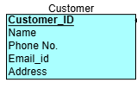

bookings: (Booking_id, customer_id, booking date, status, destination_id, package_ID, HOTEL_ID)

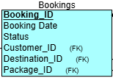

flights: (pnr, flight no, departure, arrival)

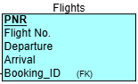

destinations: (destination_id, hotel_id, destination name, description)

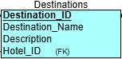

hotel: (Hotel_id, hotel name, hotel address, hotel ratings, check-in date, status, description)

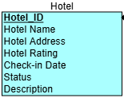

tour packages: (Package_id, GUIDE_ID, destination_id, package name, cost)

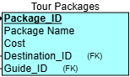

tour guides: (guide_id, guide name, phone no, email id)

